1. Leap year

import java.util.Scanner;

class leap{

public static void main(String [] args){

int y ;

Scanner s=new Scanner(System.in);

System.out.println("Enter a year ");

y=s.nextInt();

if((y % 4 == 0 && y % 100 != 0) || (y % 400 == 0))

{

System.out.println("Leap year");

}

else{

System.out.println("Not a leap year");

}

}

}

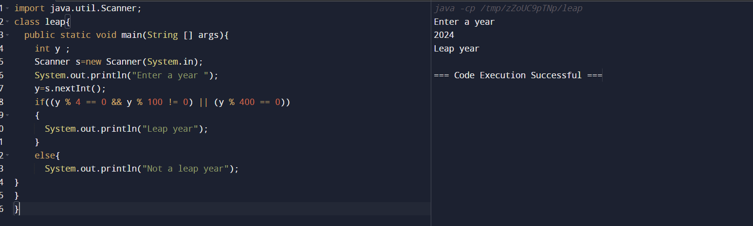

1. Two input one Output

import java.util.Scanner;

class Mul{

public static void main(String [] args){

int a,b;

Scanner sc=new Scanner(System.in);

System.out.println("Enter A : ");

a=sc.nextInt();

System.out.println("Enter B : ");

b=sc.nextInt();

System.out.println("Multiplication : "+(a\*b));

}

}

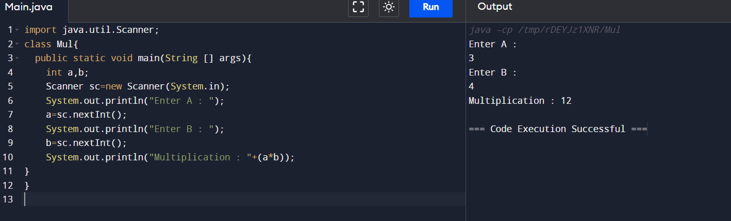

1. While loop (1 to 10)

public class While {

public static void main(String [] args){

int i=1;

while(i<=10){

System.out.println(i);

i++;

}

}

}

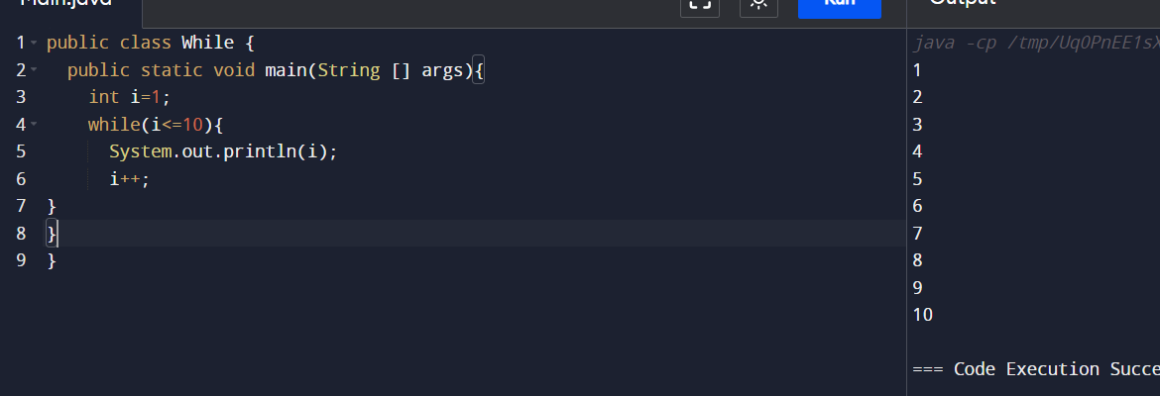

1. Continue Statement to print(1 to 10) without 5

public class cont{

public static void main(String [] args){

for(int i=1;i<=10;i++)

{

if(i==5)

{

continue;

}

System.out.println(i);

}

}

}

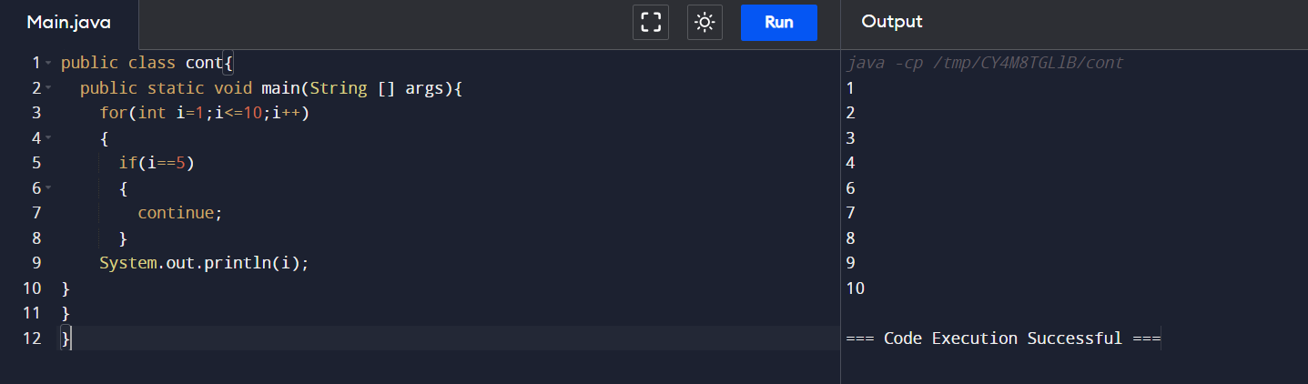

1. Break Statement

public class Break{

public static void main(String [] args){

for(int i=1;i<=10;i++){

if(i==5){

break;

}

System.out.println(i);

}

}

}

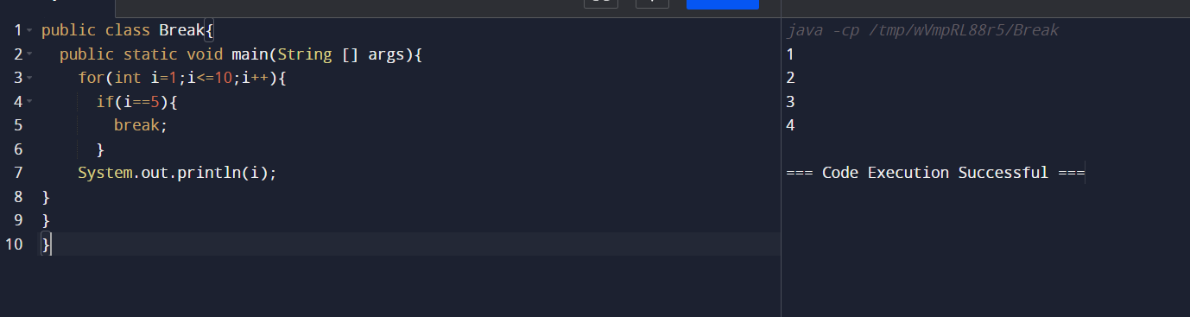

1. Nested If Else (Email pass Checker)

import java.util.Scanner;

public class emailpass {

public static void main(String[] args) {

String email;

String ogpass="12345678";

String pass;

Scanner sc = new Scanner(System.in);

System.out.println("Enter your email: ");

email = sc.nextLine();

System.out.println("Enter your password: ");

pass = sc.nextLine();

if (email.contains("@") && email.contains(".com")) {

if (ogpass.equals(pass)) {

System.out.println("Login successful!");

} else {

System.out.println("Password is incorrect");

}

} else {

System.out.println("Invalid email.");

}

}

}

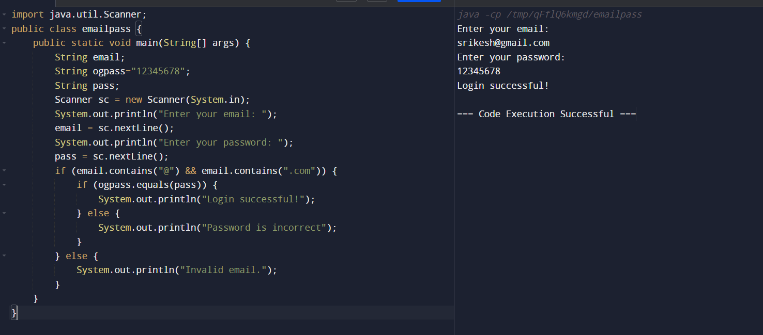

1. Getting string as input

import java.util.Scanner;

class Strings{

public static void main(String[] args){

String s;

Scanner sc=new Scanner(System.in);

System.out.print("Enter a string name : ");

s=sc.nextLine ();

System.out.println("NAME : "+s);

}

}

